11-03-2010

George K. Aidoo
SM/SMS/09/0019
Physics Practical

Experiment 8

Refraction of Light(2)

AIM:

The aim of this experiment is to determine the refractive index of a glass block using Snell's law.

APPARATUS:

Glass block (1), optical pins (4), protractor (1), drawing paper (1), and a pair of compass (1).

DIAGRAM:

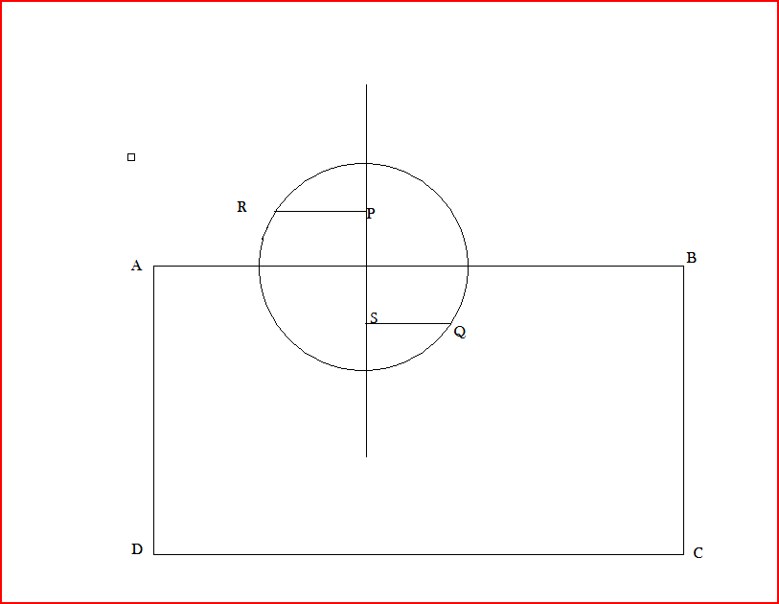

THEORY:

Snell's law, which is the law of refraction, states that:
n1sin Ө1 = n2sin Ө2, where n1 and n2 are the indices of refraction in the two media.
The incident ray, the reflected ray, the refracted ray, and the normal to the surface all lie in the same plane.

PROCEDURE:

A glass block was placed on a white sheet of paper pinned to a drawing board. The edges of the glass block were traced and the corners were labeled ABCD. The normal line was drawn through the rectangular shape. An angle of incidence i = 20º was drawn and 2 pins, P1 and P2 were pushed into the paper along the incident line to represent the incident ray. The glass block was then replaced carefully, and the images of P1 and P2 were located from the side CD of the block (the drawing). Then two pins, P3 and P4 were pinned in a straight line with the images of P1 and P2. The block was then removed and P3 and P4 were connected with a line to the side CD at point Z. This line was the emergent line. The point Z was then joined to the mergence point O.

This line represented the refracted ray. With center O, a circle was then drawn cutting the incident and the refracted rays at R and Q. Perpendicular lines RP and QS were drawn onto the normal. RP, QS, and the angle or refraction r were measured and recorded. The procedure was repeated for angles of incidence: i = 40º, 50º, 60º, 70º.

TABLE OF RESULTS:

QS / mm | Y / mm | RP / mm | R / º | I / º
7 | 14 | 11 | 12 | 20
12 | 24 | 22 | 21 | 40
17 | 35 | 27 | 29 | 50
20 | 44 | 30 | 35 | 60
22 | 50 | 32 | 38 | 70

Graph of RP vs. QS:

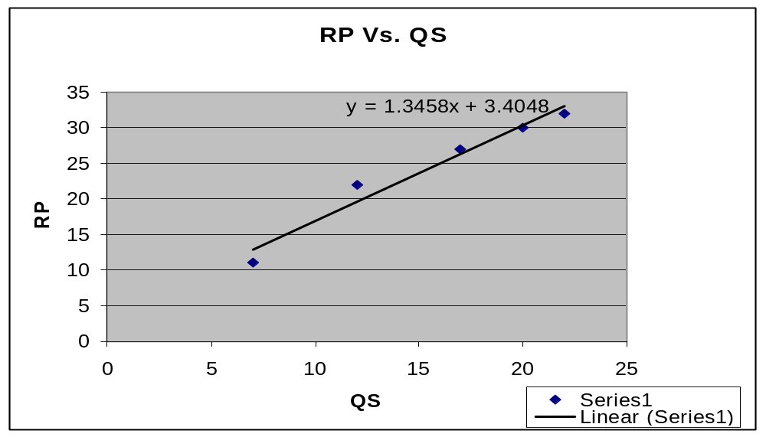

Table of Y and tan r:

Tan r / º | Y / mm
0.2125 | 14
0.3838 | 24
0.5543 | 35
0.7002 | 44
0.7812 | 50

Graph of Y vs. tan r:
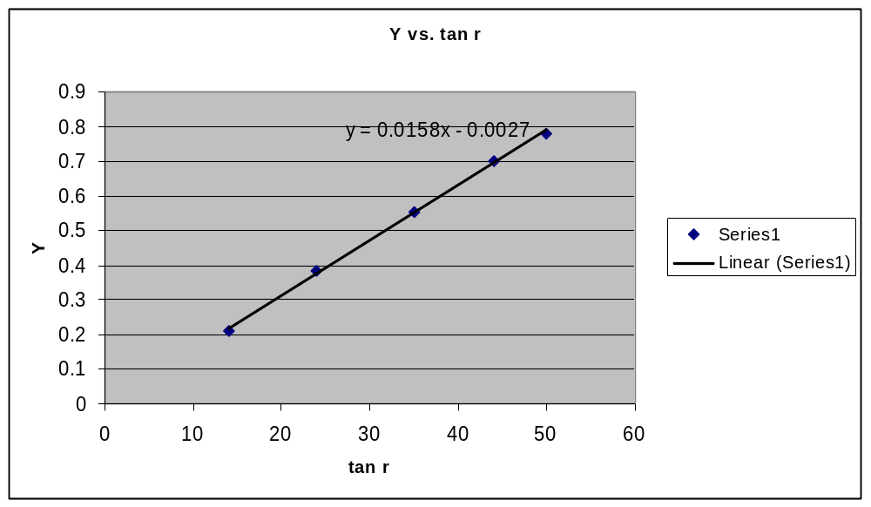

DISCUSSION:

The slope of the line in the first graph above is 1.3458. This figure represents the index of refraction of the glass medium used. The slope of the line in the second graph is 0.0158. This figure represents the width of the glass prism used in this experiment. The results prove the accuracy of Snell's law.

SOURCES OF ERRORS:

- There was a possible parallax error in placing the pins accurately when locating the images through the glass block.

PRECAUTIONS:

- Values for the angles (r) were taken many times to ensure accuracy.

- Care was taken to ensure accurate tracing of the glass block.

CONCLUSION:

The aim of the experiment to determine the refractive index of a glass block using Snell's law was successful. The refractive index of the glass block was determined to be 1.3458.

REFERENCES:

SERWAY, Raymond A., College Physics/Raymond A. Serway, Jerry S. Faughn, - 6th edition, Pacific Groove, CA 93950. USA.

Dr. Anane, University of Cape Coast; School of Medical Sciences, Cape Coast. Lecture notes; 22-02-2010.

